Cal Poly Pomona

CS470 Game Development

Spring Quarter

2017

*****************************************************************

Documentation type: Gameplay Specification

Project: The Farting Panda

Team: BaDkINgZ

Members: Mahmudur Khan,

Nathaniel Krueper,

Benjamin Krueper,

Chu Yiu Cheung,

Ian Stodart

Professor: Tony Diaz

*****************************************************************

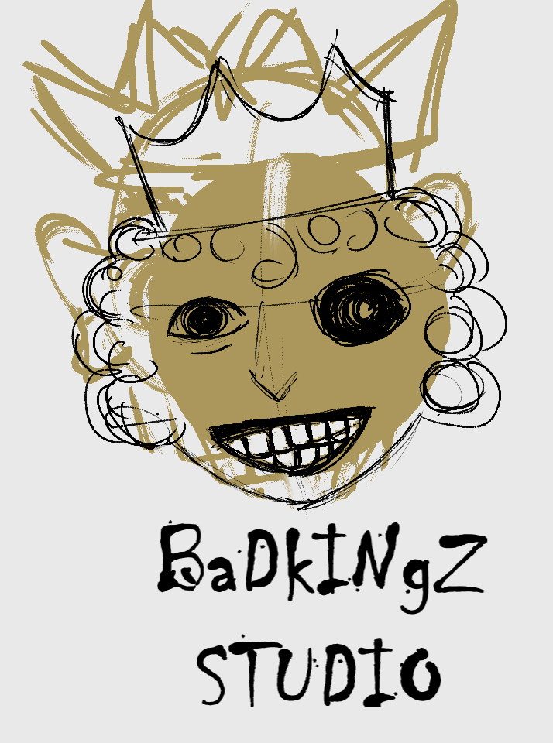

This game is a 2-d action-platformer with movement controls and level objectives similar to Mario. The player needs to traverse the treacherous terrains to reach the panda’s love. On the way, he will need to avoid hunters and get past other obstacles. The player can make use of the unique “fart” mechanic to progress. Using the fart mechanic consumes gas, which can be replenished by eating bamboo found throughout the level.

The game is normally easy to complete, but mastery of the game is required to complete it quickly. This is mainly because farting horizontally also pushes you in the opposite direction, and farting continuously like this can make you move very quickly, at the cost of control and not having fart energy for other things. This makes the game appealing for both casual and hardcore gamers.

The level can be completed using very little fart energy, but to complete it at maximum speed, you will need to fart constantly, which you don’t have enough bamboo to do. The speed runner will need to determine which points to use their limited fart energy to save the most time, leading to interesting decisions.

There are several ways to deal with the hunters, which leads to deep gameplay. You can either take them out, or avoid them. To take them out, you have to get enough gas clouds to touch them. This can be done by farting horizontally to them while on level ground, fart-rocketing above them, hiding behind cover and doing a big fart to hit them through a wall, or using your farts to make you speed up and bump into them, pushing them off a cliff. This last method is risky, since the hunters will notice you if you get close enough and shoot you point blank.

During actual gameplay, the possible player modes are paused and unpaused. While the game is not paused, the game shows the panda and the terrain around it, with the most important information like health and fart energy shown at the top of the screen.

The main objective is to reach the end of the stage, but player- made objectives also exist, like speed-running. The timer shown in the top right helps players with that objective.

**Verbs:**

There are 5 main verbs the player can do:

Walk left/right

Jump

Fart sideways

Fart up

Big fart

The combined action of jumping and farting up at the same time lets the player maintain their upwards momentum longer, allowing them to reach areas they normally would not be able to.

The combined action of farting upwards and walking allows the player to fly horizontally.

The combined action of farting sideways/walking and jumping allows the player to clear pits.

**Interactions:**

If a hunter and a gas cloud touch, the hunter will take damage.

If a hunter’s projectile and the panda touch, the panda will take damage and the projectile will disappear.

If the panda and an active trap touch, the panda will take damage and the trap will become de-activated.

If the panda and a heart touch, the panda will be healed and the heart will disappear.

If the panda and bamboo touch, the panda will gain fart energy and the bamboo will disappear.

If the panda and an inactive checkpoint touch, the checkpoint will activate and the panda’s spawn point on death will change to the checkpoint’s position.

If the panda, hunters, and walls/floors collide, the walls/floors will push them out so they don’t collide.

Gravity will pull the panda and hunters downwards.